30/01/2026

IMPORTANT UPDATE - FOOD SAFETY

Dear Parents and Carers,
We would like to remind you that Langley Green Primary is a NUT FREE school. We have many children who have severe allergies to nuts where even a small trace could cause DEATH.
Manufacturers cannot guarantee their product safety therefore we kindly ask that you DO NOT send your child to school with anything that may contain nuts.

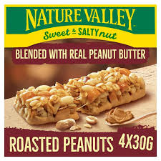
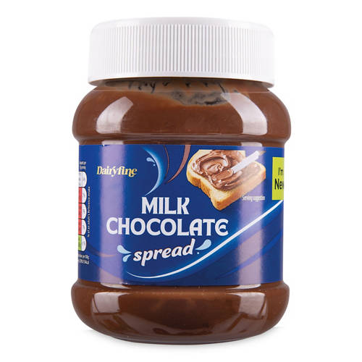
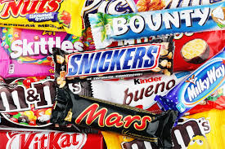
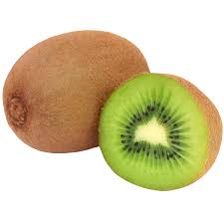
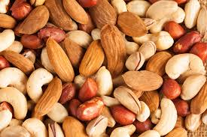
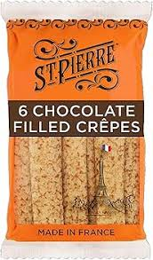
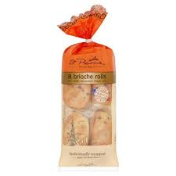
This means that chocolate spreads and any products containing nuts (or traces of nuts) should not be sent to school in lunchboxes or for snacks.
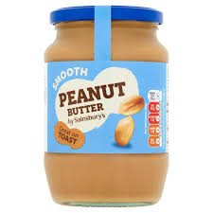
Food Safety For Under 5’s

New government safety guidance has been published on how to reduce the risk of a child choking on food. It states that
- small round fruits (grapes, strawberries, cherry tomatoes etc) should be cut lengthways and into quarters.
- Large fruits and hard vegetables (raw apple, carrots etc) should be cut into slices instead of chunks
- Sausages, cheese and breads should be cut into strips

Please also remember that sweets and popcorn are not allowed at school.

Please use the link below for alternative healthy options for your child’s packed lunch.

https://www.nhs.uk/healthier-families/recipes/healthier-lunchboxes/

We really appreciate your support in helping us keep everyone safe.

Thank you for your understanding and cooperation.

Yours sincerely

Mrs A Wallis
Head Teacher

